 **California State University Long Beach**

**College of Engineering**

**Computer Engineering Computer Science Department**

**Thursday November 20, 2016**

**Computer Architecture**

**Lab Project -2**

**Name:__Mark Levie Gumban Mendoza__**

Table of Contents

Problem Definition: 3

1) Program it in MARS 3

2) Explain its behavior 3

MARS Commented Source Code: 4

Snapshot Outputs (For each part above): 5

1) Register Picture 5

2) Memory Picture 6

3) Console Picture: 7

Problem Explanation and behavior. 8

Problem Definition:

# Problem Definition:

For the MIPS assembly instructions below,

## Program it in MARS

## Explain its behavior

1. Convert the following into code that uses a while loop.

print 2  
prints 4  
prints 6  
prints 8  
prints 10  
prints Goodbye!

**Ex. Python code:**

i = 2

while i <=10:

print (i)

i+=2

print ("Goodbye!")

1. Change the previous program, so instead of just printing the number, it should store it into memory. (Be aware of addressing every integer will take 4 bytes.)

Problem Solution:

# MARS Commented Source Code:

Part A



Part B  
  


# Snapshot Outputs (For each part above):

## Register Picture

Part A

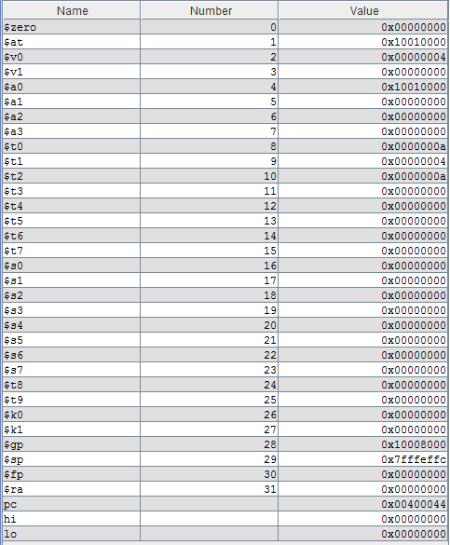

Part B  
  
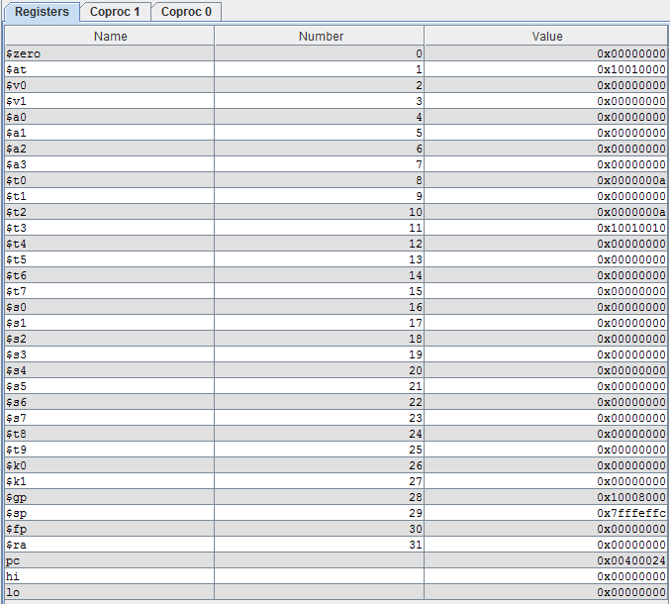

## Memory Picture

Part A

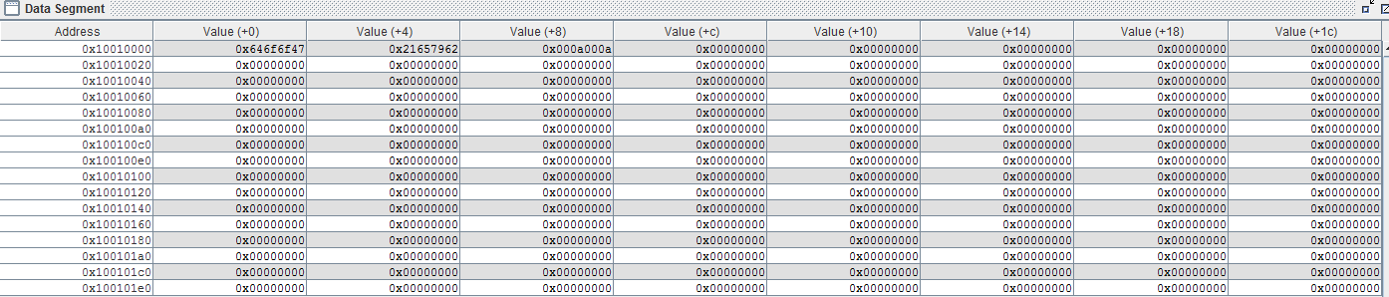

Part B

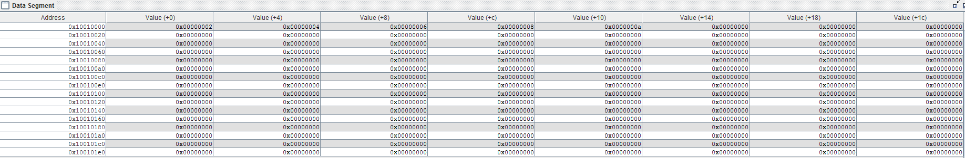

## Console Picture:

Part A

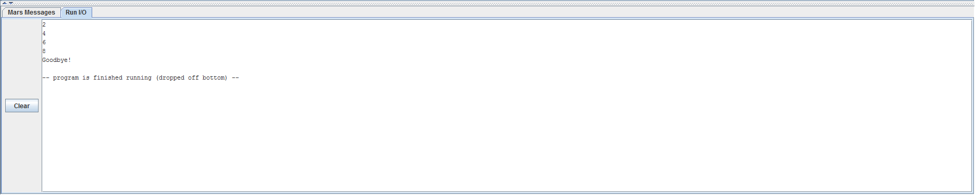

Part B  
  
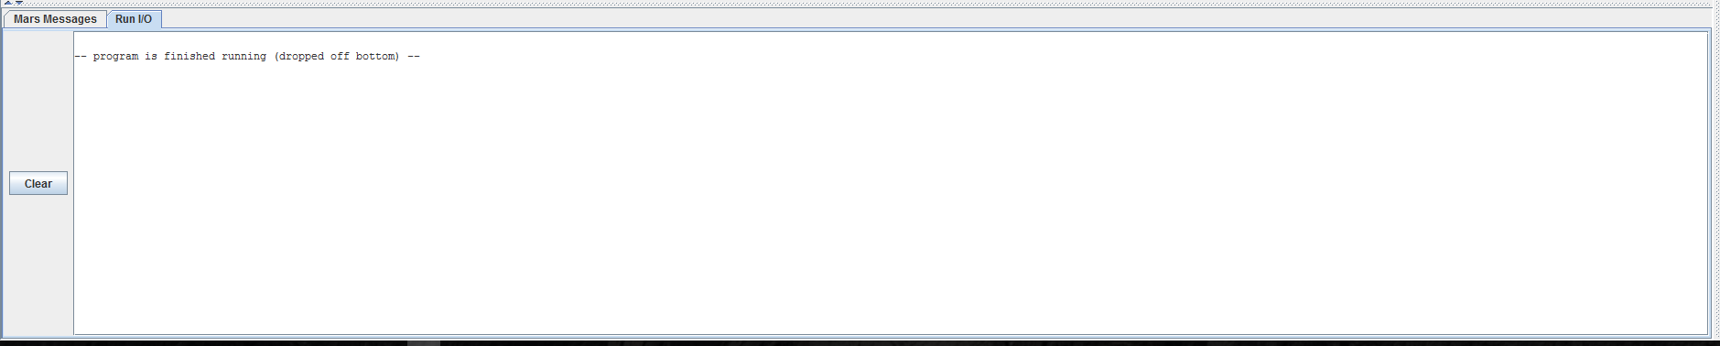

# Problem Explanation and behavior.

The problem asks us to translate 5 lines of python code into MIPS assembly, and within the original python code the 2 and increments + 2 up until 10 is printed.

For the second part of the problem, the problem asks us instead of printing it out, it wants us to store the 2 and it’s increments into memory.

## Behavior:

The program starts off at 2, and using a loop increments that number by 2 until we get to 10, and depending on the part we print out the results of the increment or store it in the memory, and if we store it in memory the index where we are writing to is incremented in each loop.